Practical 6 – Product Review Testing
Module Name: Product Review Module
Webpage URL: https://demo.nopcommerce.com/

Test Case ID: TC01
Scenario: Verify product review submission with valid input.
Steps:
- Open nopCommerce website.
- Open a product page.
- Open the product review section.
- Enter valid review text and select a valid rating.
- Submit the review.
- Observe the result.
screenshot: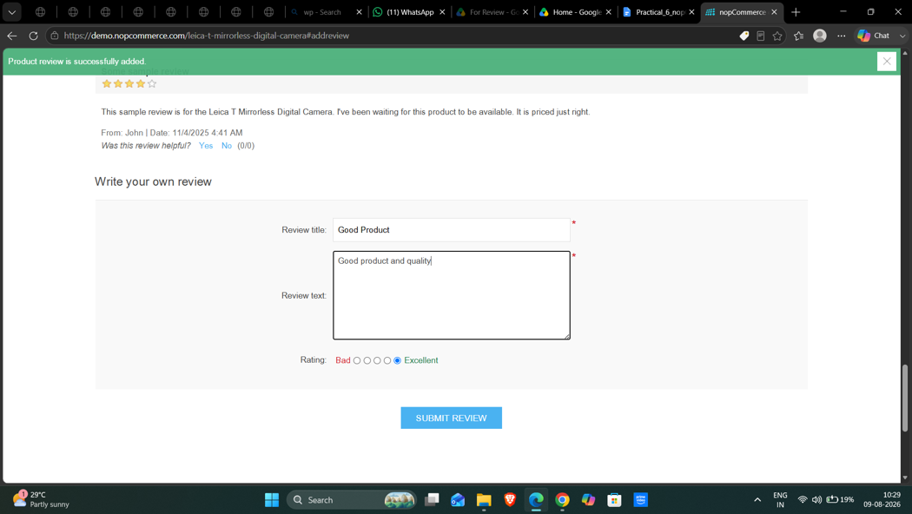
Expected Result: Review should be accepted and submitted successfully.
Actual Result: Valid Review Title and Review Text were entered, Excellent rating was selected, and the message “Product review was successfully added” was displayed.
Status: Pass

Test Case ID: TC02
Scenario: Verify product review with blank review title.
Steps:
- Open nopCommerce website.
- Open a product page.
- Open the product review section.
- Leave the Review Title blank, enter valid Review Text, and select Excellent rating.
- Submit the review.
- Observe the result.
screenshot: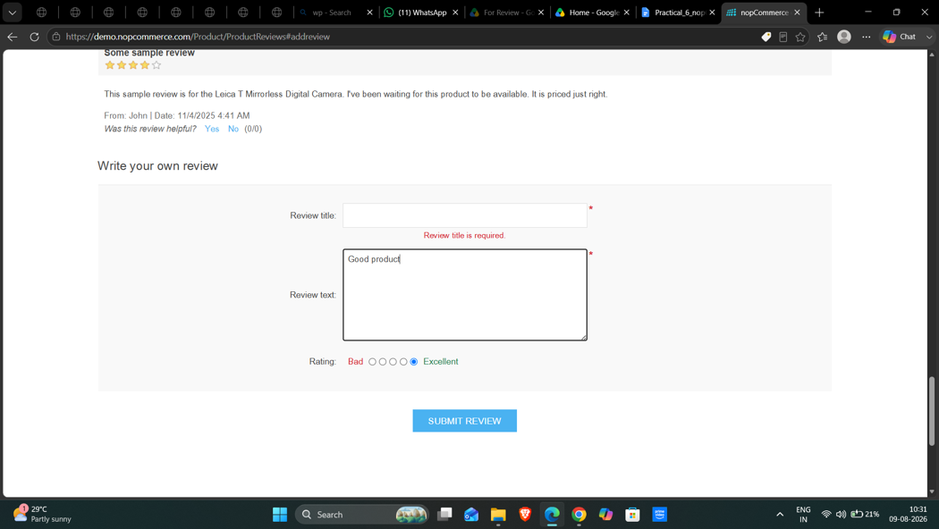
Expected Result: System should display an appropriate validation message.
Actual Result: Review Title was left blank while Review Text was entered. The page displayed “Review title is required” and the review was not submitted.
Status: Pass

Test Case ID: TC03
Scenario: Verify product review with blank review text.
Steps:
- Open nopCommerce website.
- Open a product page.
- Open the product review section.
- Enter a valid Review Title, leave Review Text blank, and select Excellent rating.
- Submit the review.
- Observe the result.
screenshot: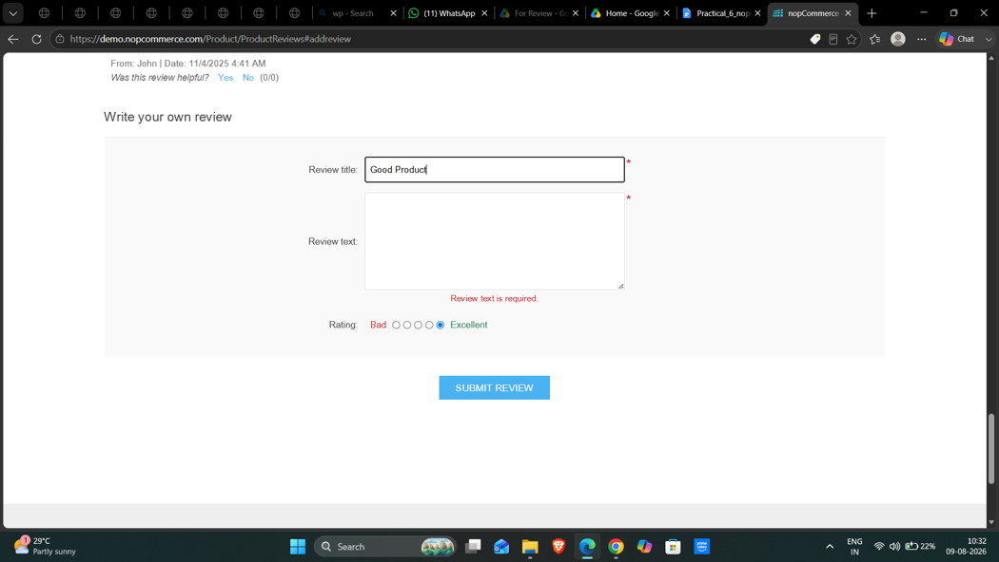
Expected Result: System should display an appropriate validation message.
Actual Result: Review Title was entered while Review Text was left blank. The page displayed “Review text is required” and the review was not submitted.
Status: Pass

Test Case ID: TC04
Scenario: Verify product review with blank review and rating.
Steps:
- Open nopCommerce website.
- Open a product page.
- Open the product review section.
- Leave the review fields blank and do not select a rating.
- Submit the review.
- Observe the result.
screenshot: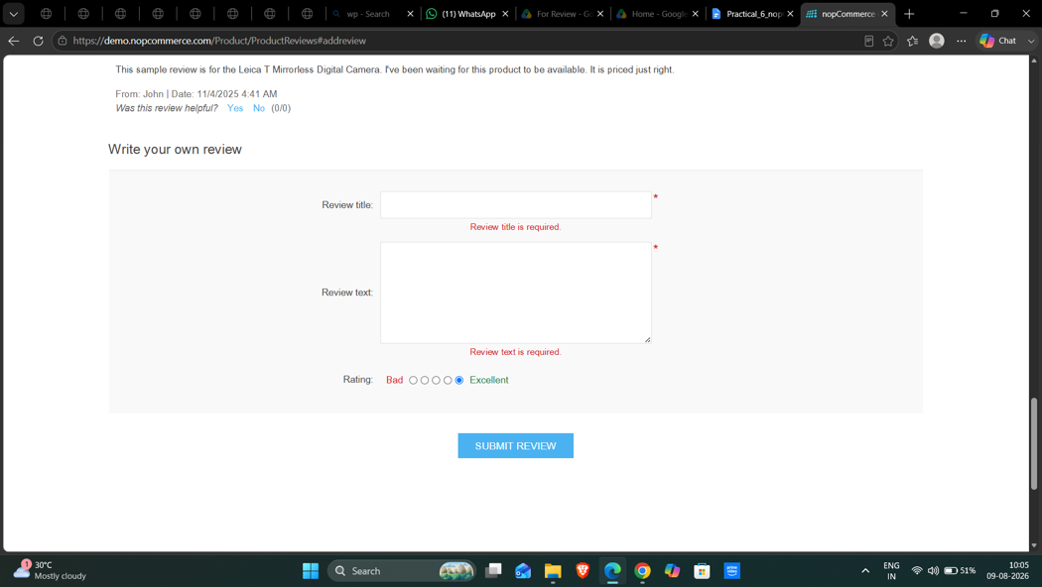
Expected Result: System should display validation messages and should not submit the review.
Actual Result: Required-field validation was displayed and the review was not submitted.
Status: Pass

Test Case ID: TC05
Scenario: Verify product review with special characters.
Steps:
- Open nopCommerce website.
- Open a product page.
- Open the product review section.
- Enter the test input @@@###$$$ in Review Text.
- Submit the review.
- Observe the result.
screenshot: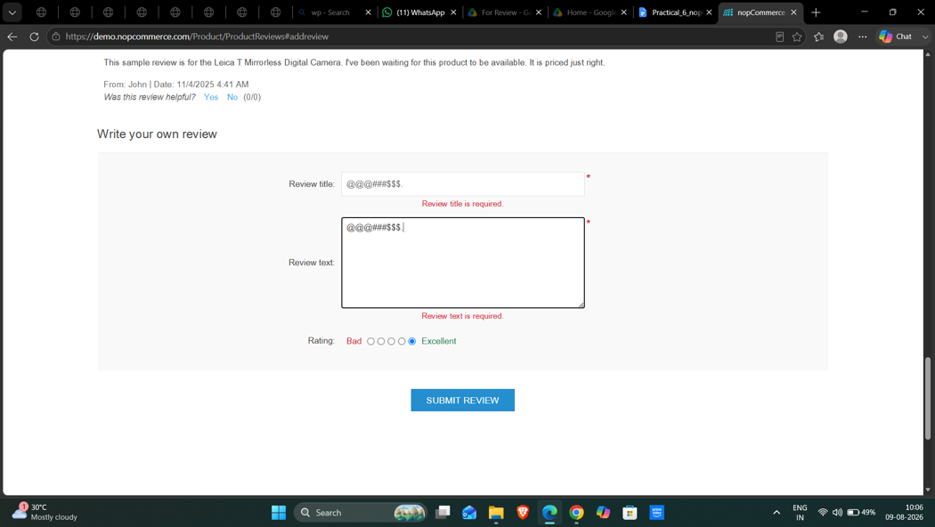
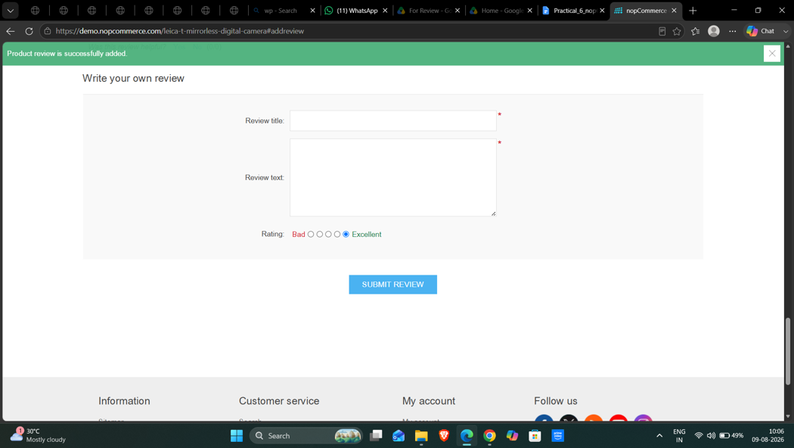
Expected Result: System should handle the input correctly and display an appropriate validation/result message.
Actual Result: Special-character input was accepted and the product review was submitted successfully.
Status: Pass

Test Case ID: TC06
Scenario: Verify product review with numeric input.
Steps:
- Open nopCommerce website.
- Open a product page.
- Open the product review section.
- Enter the test input 123456789 in Review Text.
- Submit the review.
- Observe the result.
screenshot: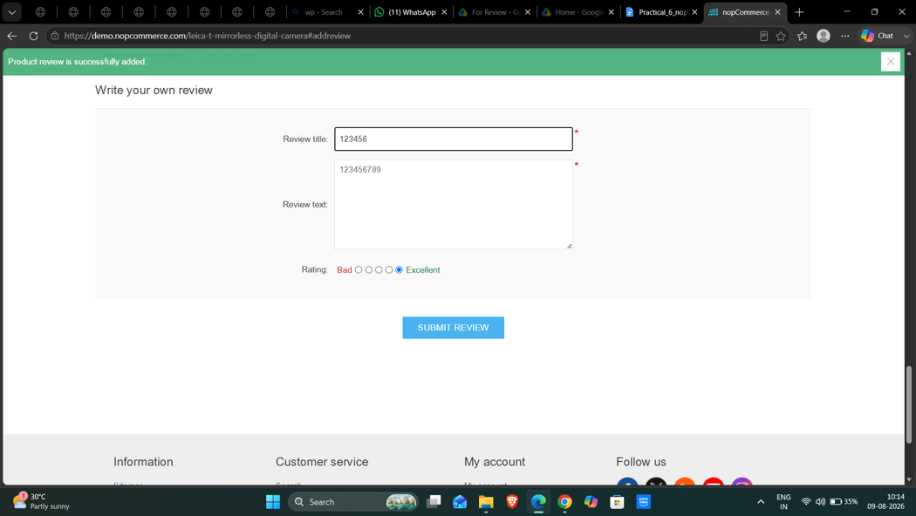
Expected Result: System should validate the input according to the review field rules.
Actual Result: Numeric input was accepted and the product review was submitted successfully.
Status: Pass

Test Case ID: TC07
Scenario: Verify product review with valid text and invalid rating condition.
Steps:
- Open nopCommerce website.
- Open a product page.
- Open the product review section.
- Enter valid review text and select Bad rating.
- Submit the review.
- Observe the result.
screenshot: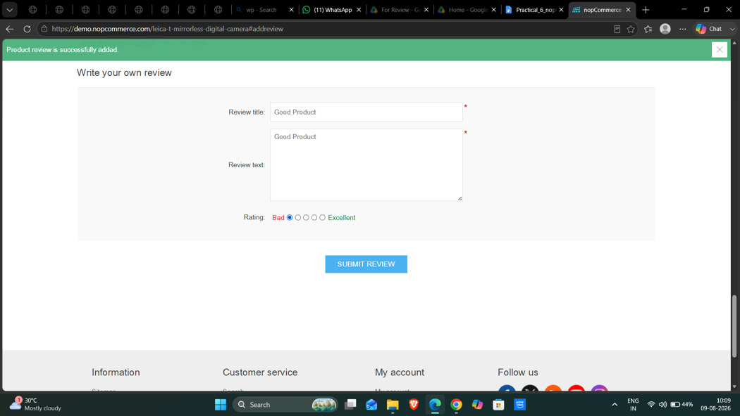
Expected Result: System should validate the rating and prevent submission if the rating is invalid.
Actual Result: The selected Bad rating was accepted with valid review information, and no validation error was displayed.
Status: Pass

Test Case ID: TC08
Scenario: Verify product review with alphabetic valid input.
Steps:
- Open nopCommerce website.
- Open a product page.
- Open the product review section.
- Enter good product in Review Text.
- Submit the review.
- Observe the result.
screenshot: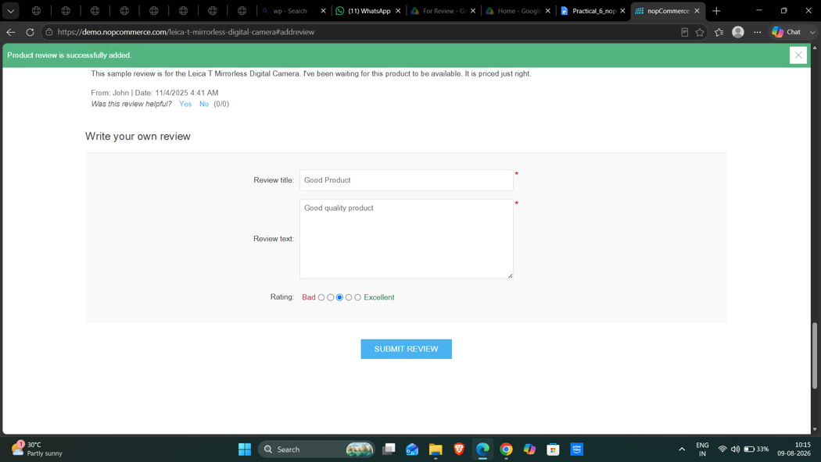
Expected Result: Review should be accepted and processed correctly.
Actual Result: The review with Good rating was submitted successfully.
Status: Pass

Test Case ID: TC09
Scenario: Verify product review with mixed valid text and numbers.
Steps:
- Open nopCommerce website.
- Open a product page.
- Open the product review section.
- Enter in Review good product 123 Text.
- Submit the review.
- Observe the result.
screenshot: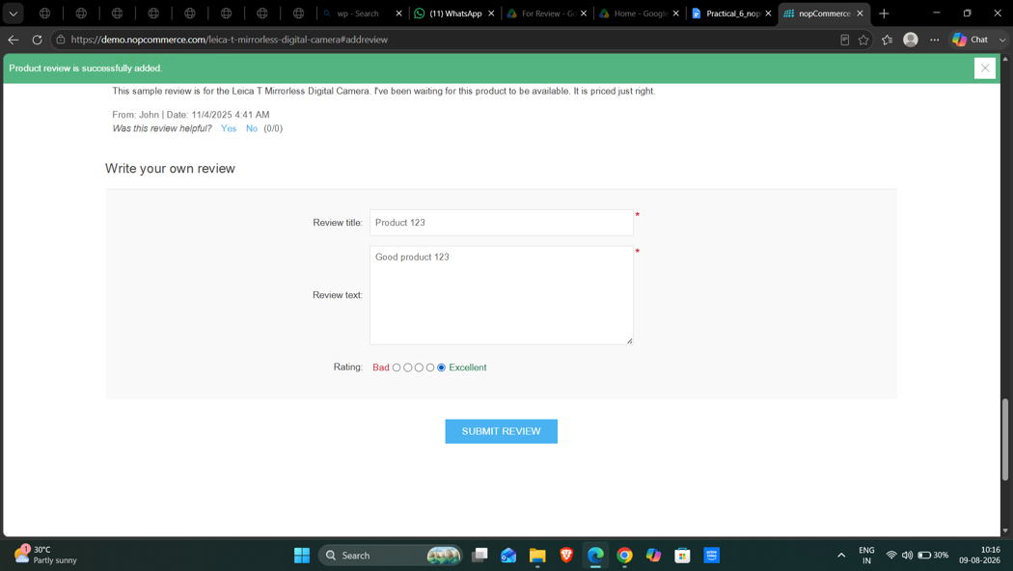
Expected Result: System should process the review according to the field validation rules.
Actual Result: Mixed text and numeric review input was accepted and submitted successfully.
Status: Pass

Test Case ID: TC10
Scenario: Verify product review with blank/space input.
Steps:
- Open nopCommerce website.
- Open a product page.
- Open the product review section.
- Enter only spaces in Review Text.
- Submit the review.
- Observe the result.
screenshot: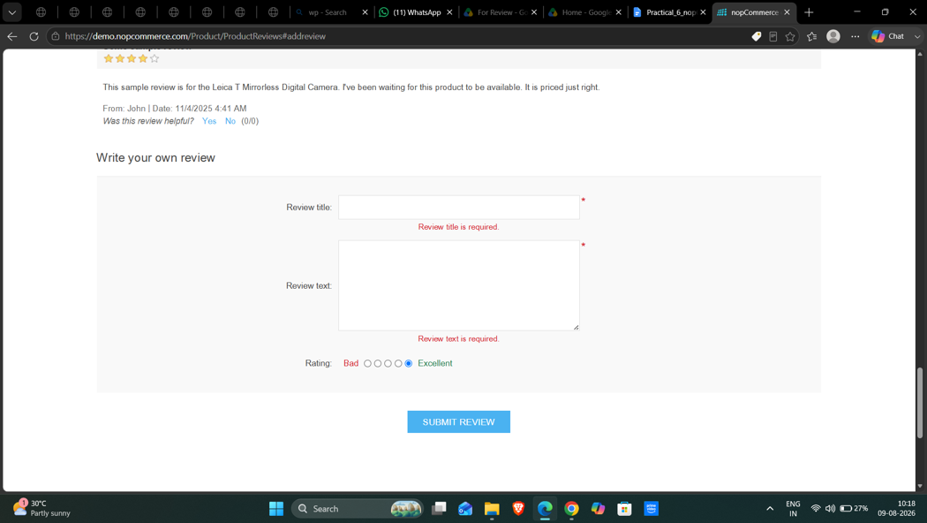
Expected Result: System should validate the input and should not accept whitespace-only review text.
Actual Result: Blank/whitespace validation prevented an invalid review submission.
Status: Pass

